

**Software Requirement Specification**

**Project name: BoonBo Shop**

**Author: Group 5**

– Hanoi, March 2023 –

# **Record of changes**

| **Date** | **A, M, D** | **In charge** | **Description** |
| --- | --- | --- | --- |
| 02/02 | A | Mai Phuong Linh | Overview |
| 08/02 | A | Can Duy Khanh | ERD |
| 11/02 | A | Bui Quang Truong | Functional requirement |
| 11/02 | A | Nguyen Tuan Linh | Functional requirement |
| 12/2 | A | Mai Ngoc Giang | Functional requirement |
| 12/02 | A | Nguyen Tuan Linh | Functional requirement |
| 12/02 | A | Mai Phuong Linh | Functional requirement |
| 14/02 | A | Can Duy Khanh | Functional requirement |
| 16/02 | A | Mai Ngoc Giang | Functional requirement |
| 18/02 | M | Mai Phuong Linh | Context digram |
| 27/02 | M | Can Duy Khanh | Functional requirement |
| 28/02 | M | Bui Quang Truong | Functional requirement |
| 03/03 | A | Nguyen Tuan Linh | Functional requirement |
| 03/03 | A | Mai Phuong Linh | Functional requirement |
| 09/03 | A | Can Duy Khanh | Functional requirement |
| 10/03 | M | Mai Ngoc Giang | Functional requirement |
| 10/03 | A | Mai Ngoc Giang | Functional requirement |
| 14/03 | M | Nguyen Tuan Linh | Functional requirement |
| 14/03 | A | Nguyen Tuan Linh | Functional requirement |
| 16/03 | M | Mai Phuong Linh | Functional requirement |
| 16/03 | A | Mai Phuong Linh | Functional requirement |
| 18/03 | A | All | Functional requirement |

*A - Added M - Modified D - Deleted

# **Table of Contents**

**I. Overview**…………………………………………………………………….

1. Introduction…………………………………………………………………

2. System Functions……………………………………………………………

3. Entity Relationship Diagram………………………………………………..

**II. Functional Requirements……………………………………………….. 10**

1. Manage account……………………………………………………………..10

1.1 Add account……………………………………………………………….11

1.2 View account………………………………………………………………12

1.3 Edit account………………………………………………………………..13

1.4 Delete account……………………………………………………………..14

2. Manage order………………………………………………………………..15

2.1 Edit order………………………………………………………………….16

2.2 Delete order……………………………………………………………….17

2.3 View order………………………………………………………………...18

3. Manage personal profile……………………………………………………20

3.1 View profile……………………………………………………………….20

3.2 Update profile……………………………………………………………..20

3.3 View own orders and detail order…………………………………………22

3.4 Manage address……………………………………………………………23

3.4.1 Add address……………………………………………………………...24

3.4.2 Edit address……………………………………………………………...25

3.4.3 Delete address…………………………………………………………...26

3.5 Change password………………………………………………………….27

4. Manage product…………………………………………………………….28

4.1 Update product……………………………………………………………29

4.2 Delete product…………………………………………………………….31

4.3 Add product……………………………………………………………….32

4.4 View product………………………………………………………………32

5. Action with shopping cart…………………………………………………..34

6. Feedback……………………………………………………………………35

7. Common feature……………………………………………………………36

7.1 Register……………………………………………………………………36

7.2 Login………………………………………………………………………37

7.3 Logout……………………………………………………………………..39

7.4 Forgot password…………………………………………………………...40

7.5 Search product…………………………………………………………….41

7.5.1 Search product by name…………………………………………………41

7.5.2 Search product by title………………………………………………….43

7.5.3 Search product by category, gender…………………………………….44

7.6 Home page………………………………………………………………..45

# **Overview**

## **1. Introduction**

Boon Bo is an online sales website for a perfume company. This system supports sellers as well as customers to be able to transact, buy and sell more conveniently and save time.

The website system is expected to launch in the near future and will be available to users as soon as possible.

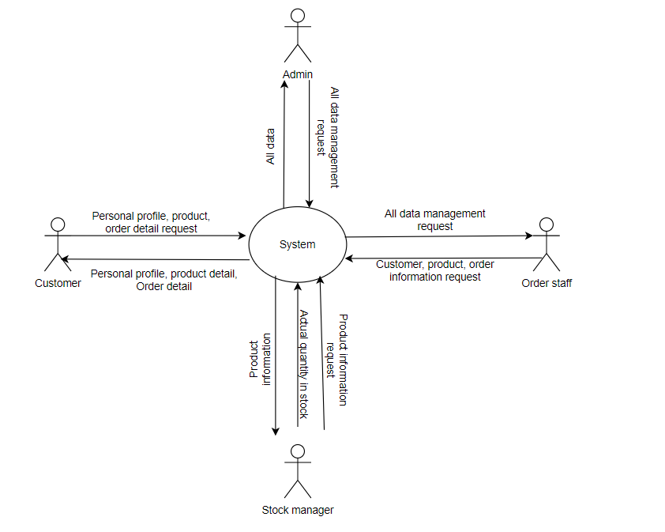

<https://app.diagrams.net/#G1rVlBtZx1UAqijoNMbENlhkJobYdByvfH>

## **2. System Functions**

### **a. Screen flow**

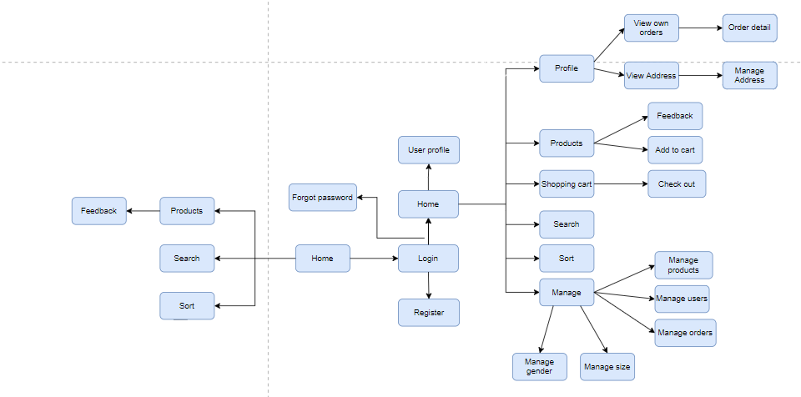

<https://app.diagrams.net/#G1rVlBtZx1UAqijoNMbENlhkJobYdByvfH>

### **b. Screen Details**

| **#** | **Feature** | **Screen** | **Description** |
| --- | --- | --- | --- |
| 1 | Register | register | Create a new account. |
| 2 | Authentication | login, logOut | Login and sign up for users. |
| 3 | Forgot password | Forgot password | User enter email, system will send a code OTP to verify |
| 4 | View profile | profile | View user profile |
| 5 | Update profile | Change profile | Update information of user |
| 6 | Change password | Change password | Change password |
| 7 | Search product | search | Search and display the product the user wants to find |
| 8 | Sort product | sort | sort products by criteria |
| 9 | View product detail | productdetail | Display detail of product |
| 10 | View Shopping cart | Shopping cart | Display items in cart |
| 11 | Buy product | order | Create order |
| 12 | Manage Product | addproduct  updateproduct  deleteproduct | CRUD application for Product |
| 13 | Manage Order | addorder  updateorder | CRUD application for Order |
| 14 | Manage User | adduser  updateuser  deleteuser | CRUD application for User |
| 15 | Manage Address | addaddress  editaddress  deleteaddress | CRUD for Address_Detail |

### **c. User Authorization**

| **Role** | **Name** | **Description** |
| --- | --- | --- |
| 1 | Admin | Manage all purchases, products, users |
| 2 | Order staff | Check order status  Check quantity on the web  Manage customer |
| 3 | Stock manager | Check the actual quantity in stock |
| 4 | Customer | Buyer |

| **Screen** | **Role 1** | **Role 2** | **Role 3** | **Role 4** |
| --- | --- | --- | --- | --- |
| Home | x | x | x | x |
| Login, Logout, Register | x | x | x | x |
| View profile | x | x | x | x |
| View product, shopping cart | x | x | x | x |
| Query all data | x |  |  |  |
| Query own data | x | x | x | x |
| Query managed data | x | x | x |  |
| Add new data | x | x | x |  |
| Add new own data | x | x | x | x |
| Update all Data | x |  |  |  |
| Update own data | x | x | x | x |
| Update managed data | x | x | x |  |
| Delete managed data | x | x | x |  |
| Delete own data | x | x | x | x |

### **d. Non-screen function**

| **#** | **Feature** | **System Function** | **Description** |
| --- | --- | --- | --- |
| 1 | Send OTP |  | Send OTP to mail to verify forgetting password |
| 2 | Login with Gmail |  | Login by Gmail account |
| 3 | Paging |  | Split pages to avoid a screen with too many elements |

## 

## **Entity Relationship Diagram**

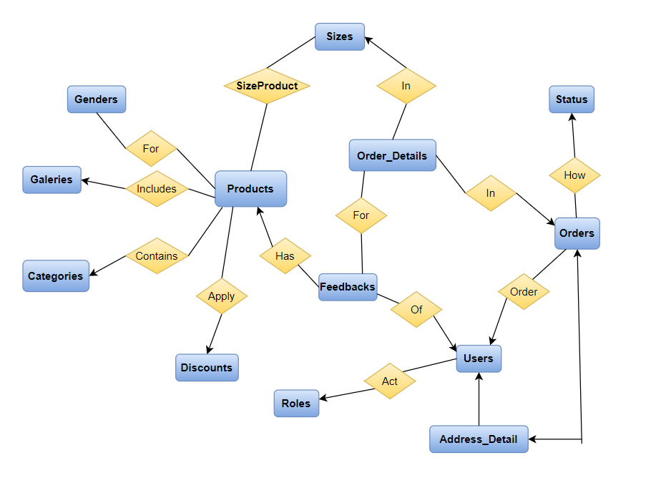

<https://app.diagrams.net/#G1rVlBtZx1UAqijoNMbENlhkJobYdByvfH>

### **Entity Description**

| **#** | **Entity** | **Description** |
| --- | --- | --- |
| 1 | Users | Include admin, order staff, stock manager, customer |
| 2 | Products | Products sold on the web |
| 3 | Orders | Order when buying |
| 4 | Order_Details | Detail of each items in order |
| 5 | Feedbacks | Feedback of customer for each product |
| 6 | Categories | Categories of product |
| 7 | Genders | Product classification criteria |
| 8 | Sizes | Size of product |
| 9 | Discounts | Discount based on order value |
| 10 | Galeries | Contain photos of products |
| 11 | Roles | Role of user |
| 12 | Status | Status of order |
| 13 | Address_Detail | Address of user |

# **II.** **Functional Requirements**

### **1. Manage account**

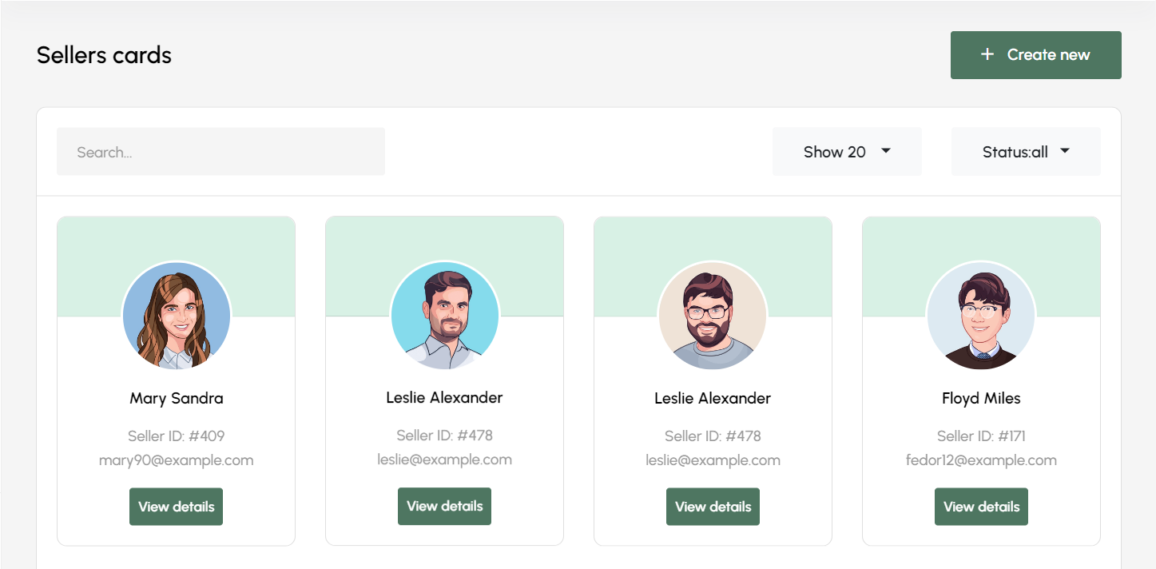

| **Name** | Manage account | **Actor:** Admin, Order staff |
| --- | --- | --- |
| **Description:** | This function allows actor to view all accounts in the system | |
| **Trigger** | When the actor logged in. | |
| **Preconditions** | **PRE-1**. Actor has logged in the system with an admin account | |
| **Post-conditions** | **POST-1**. The system displays the account list. | |
| **Normal Flows** | **Actor actions** | **Actor actions System responses** |
|  | 1. Display screen management with a list of accounts. |

**1.1 Add account**

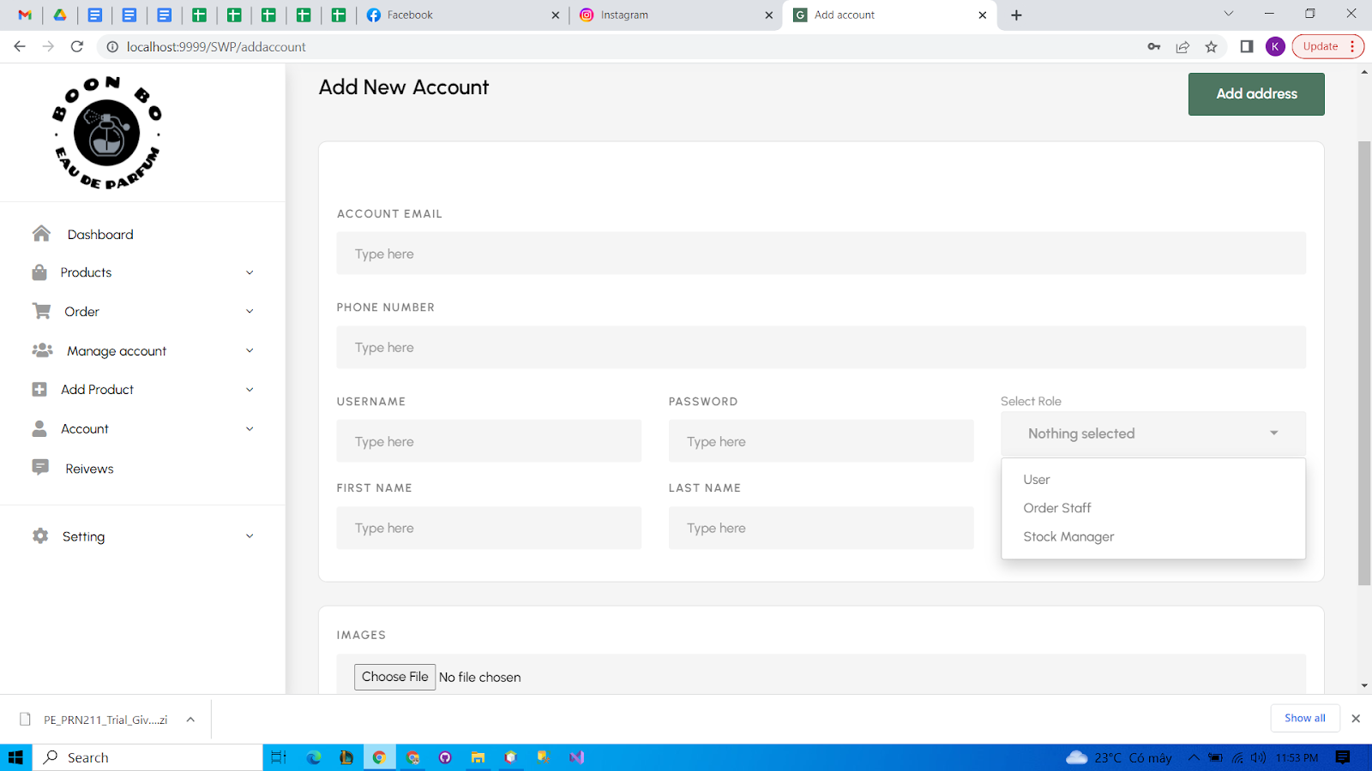

| **Name** | Add account | **Actor:** Admin |
| --- | --- | --- |
| **Description** | This function allows actors to add a new account. | |
| **Trigger** | Actor clicks on the button “Create New” | |
| **Preconditions** | **PRE-1.** Actor has logged in the system with an admin account.  **PRE-2.** Actor accesses the account management page | |
| **Post-conditions** | **POST-1.** The system displays a list of accounts with a new account added.  **POST-2.** A new account has been added to the database. | |
| **Normal Flows** | **Actor actions** | **System responses** |
| 1. Click on the create new button.  3. Input information of a new account.  4. Click on the “Add address” button. | 2. Display a pop-up form to fill in the new account information.  5. Display a pop-up message: “Thêm tài khoản thành công.” |

**1.2 View account**

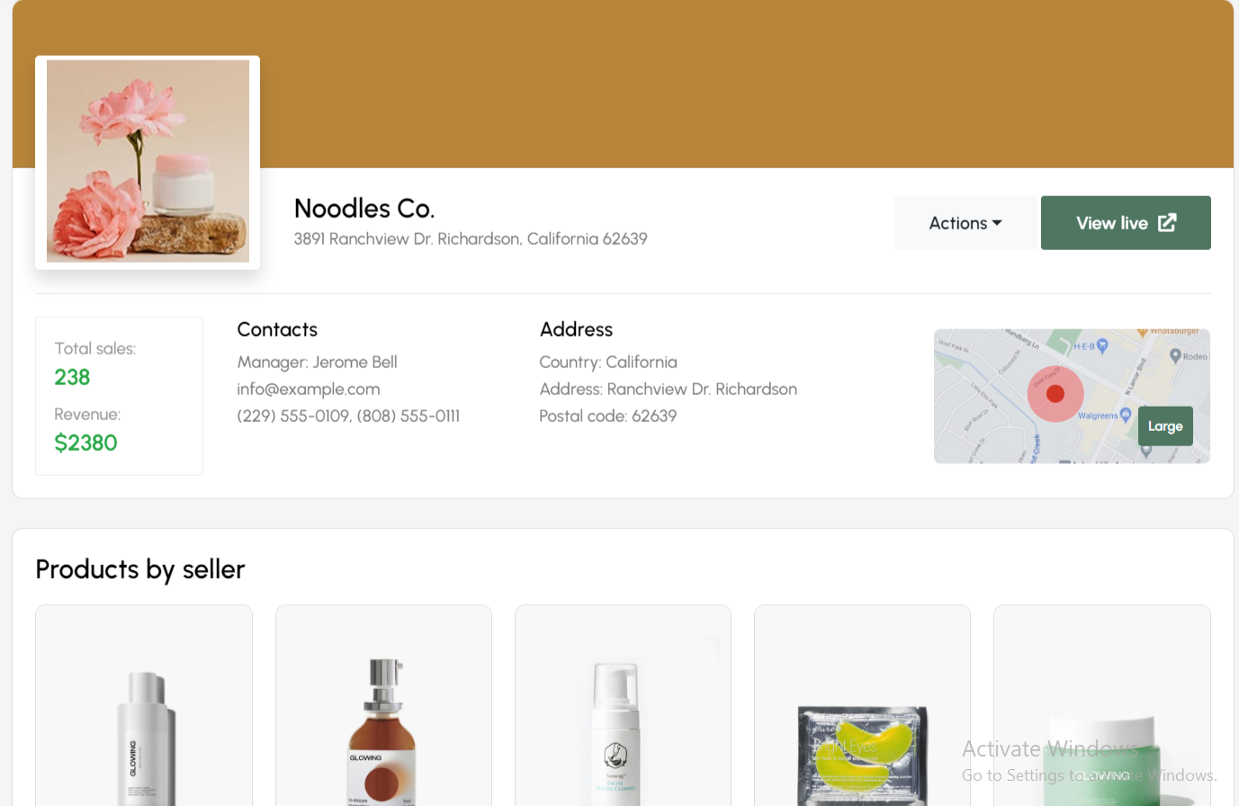

| **Name** | View account | **Actor:** Admin |
| --- | --- | --- |
| **Description** | This function allows the actor to view an account’s information. | |
| **Trigger** | Actor clicks on the view detail button | |
| **Preconditions** | **PRE-1.** Actor has logged in the system with an admin account.  **PRE-2.** Actor accesses the account management page. **PRE-3.** Account list must have at least 1 account. | |
| **Post-conditions** | **POST-1.** The system displays information about an account. | |
| **Normal Flows** | **Actor actions** | **System responses** |
| 1. Click on the view detail buttonon the account to view detail. | 2. Display a pop-up form with the account information. |

**1.3 Edit account**

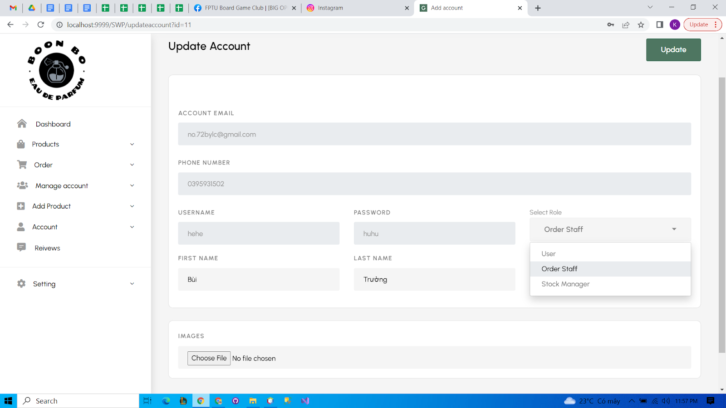

| **Name** | Edit account | **Actor:** Admin |
| --- | --- | --- |
| **Description** | This function allows the actor to edit the information of an account. | |
| **Trigger** | Actor clicks on the update button | |
| **Preconditions** | **PRE-1.** Actor has logged in the system with an admin account.  **PRE-2.** Actor accesses the account management page. **PRE-3.** Account list must have at least 1 account. | |
| **Post-conditions** | **POST-1.** The system displays a list of accounts with the edited account.  **POST-2.** The account information in the database has been updated with new information. | |
| **Normal Flows** | **Actor action** | **System responses** |
| 1. Click on the update button at the place which has the account to edit.  3. Edit account information.  4. Click the “Lưu” button. | 2. Display a pop-up form to edit account information.  5. Display message: “Đã lưu” |

**1.4 Delete account**

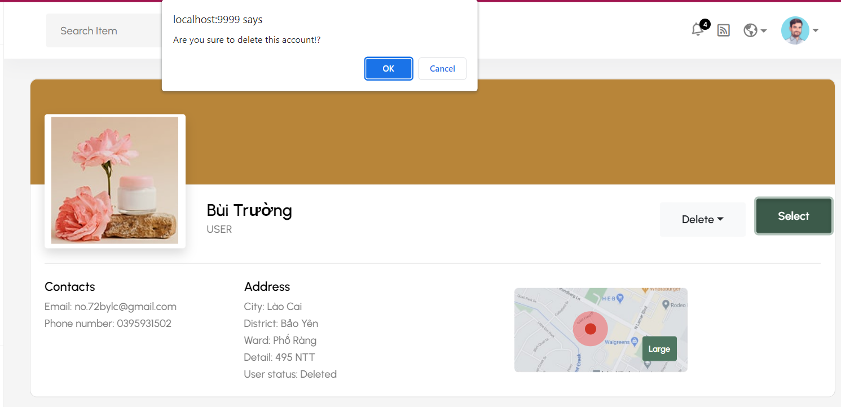

| **Name** | Delete account | **Actor:** Admin |
| --- | --- | --- |
| **Description** | This function allows the actor to delete an account. | |
| **Trigger** | Actor clicks on the delete button | |
| **Preconditions** | **PRE-1.** Actor has logged in the system with an admin account.  **PRE-2.** Actor accesses the account management page. **PRE-3.** Account list must have at least 1 account. | |
| **Post-conditions** | **POST-1.** The system displays a list of accounts without a deleted account.  **POST-2.** The account information in the database has been updated with the disabled status. | |
| **Normal Flows** | **Actor actions** | **System responses** |
| 1. Click on the delete button at the place which has the account to delete.  3. Click the “Có” button. | 2. Display a pop-up message: “Bạn muốn xóa tài khoản này?”  4. Display message: “Xóa tài khoản thành công” |

### **2. Manage order**

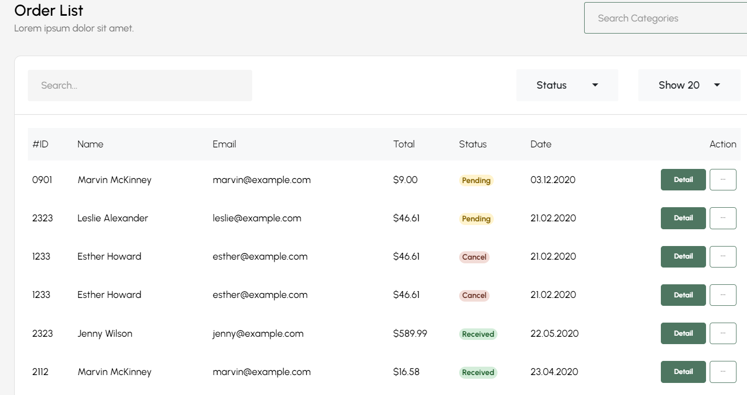

| **Name** | Manage order | **Actor:** admin, order staff |
| --- | --- | --- |
| **Description** | This function allows actor to view all orders in the system | |
| **Trigger** | When the actor accesses the order management page. | |
| **Preconditions** | Actor has logged in the system with an admin account or order staff account | |
| **Post-conditions** | The system displays the order list. | |
| **Normal Flows** | Actor action | System responses |
| Click on “Manage order” button | Display screen management with a list of orders |

**2.1 Edit order**

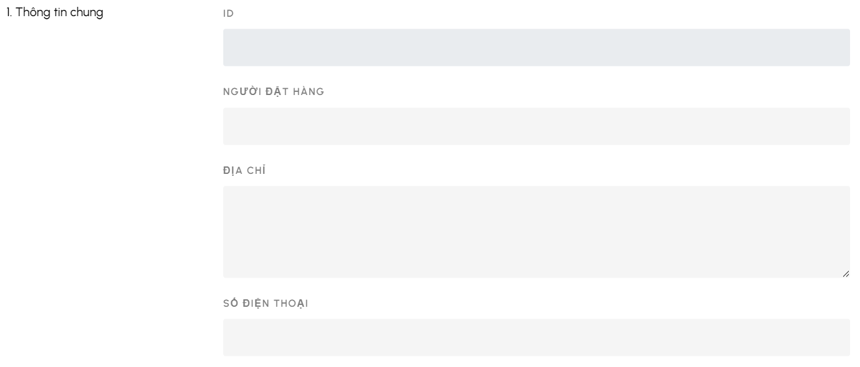

| **Name** | Edit order | **Actor:** admin, order staff |
| --- | --- | --- |
| **Description** | This function allows the actor to edit the information of an order. | |
| **Trigger** | Actor clicks on the edit icon in the “Thao tác” column. | |
| **Preconditions** | 1. Actor has logged in the system with an admin account or order staff account.  2. Actor accesses the order management page.  3. Order list must have at least 1 order. | |
| **Post-conditions** | 1. The system displays order management  2. The order information in the database has been updated with new information. | |
| **Normal Flows** | Actor action | System responses |
| 1. Click on the edit icon at the row which has the order to edit.  3. Edit account information.  4. Click the “Lưu” button. | 2. Display a pop-up form to edit account information.  5. Display message: “Đã lưu” |

**2.2 Delete order**

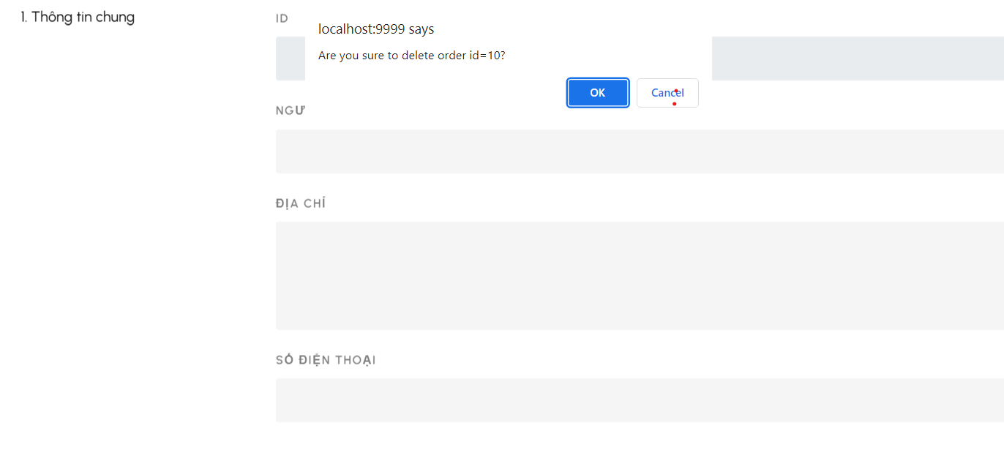

| **Name** | Delete order | **Actor:** admin, order staff |
| --- | --- | --- |
| **Description** | This function allows the actor to delete an order. | |
| **Trigger** | Actor clicks on the delete icon in the “Thao tác” column. | |
| **Preconditions** | 1. Actor has logged in the system with an admin account or order staff account.  2. Actor accesses the order management page.  3. Order list must have at least 1 order. | |
| **Post-conditions** | 1. The system displays order management  2. The order information in the database has been updated with new information. | |
| **Normal Flows** | Actor action | System responses |
| 1. Click on the delete icon at the row which has the order to edit.  3. Click “OK” in confirmation.. | 2. Display a pop-up message: “Bạn muốn xóa đơn hàng này?”  4. Display message: “Đã lưu” |

**2.3 View Order**



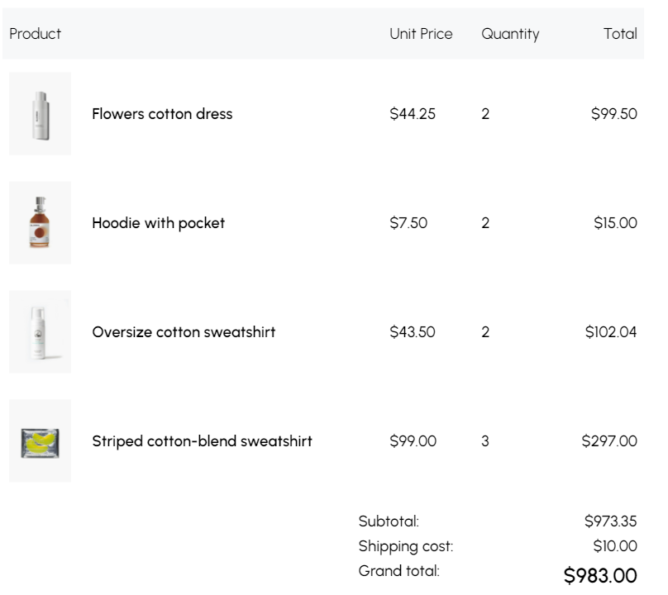

| **Name** | View order | **Actor:** admin, order staff |
| --- | --- | --- |
| **Description** | This function allows the actor to view details in an order. | |
| **Trigger** | Actor clicks on the delete icon in the “Chi tiết” column. | |
| **Preconditions** | 1. Actor has logged in the system with an admin account or order staff account.  2. Actor accesses the order management page.  3. Order list must have at least 1 order. | |
| **Post-conditions** | The system displays details of order. | |
| **Normal Flows** | Actor action | System responses |
| 1. Click on the “Chi tiết button” at the row which has the order to edit. | 2. Display detail order page with all information of the order |

### **3 Manage personal profile**

**3.1 View profile**

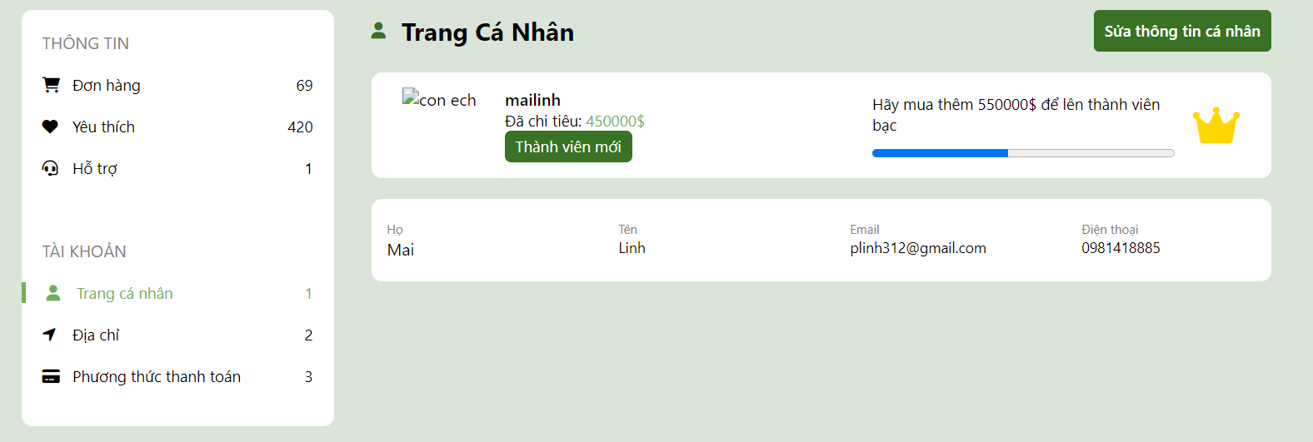

| **Name** | View profile | **Actor:** all user |
| --- | --- | --- |
| **Description** | This function allows actors to access personal profile pages to view their own information. | |
| **Trigger** | Actor clicks on the delete icon in the profile icon on the home page. | |
| **Preconditions** | Actor has logged in the system. | |
| **Post-conditions** | The system displays account information. | |
| **Normal Flows** | Actor action | System responses |
| 1. Click on the profile icon in the navigation bar. | 2. Display information of account  4. Display a pop-up |

**3.2 Update profile** 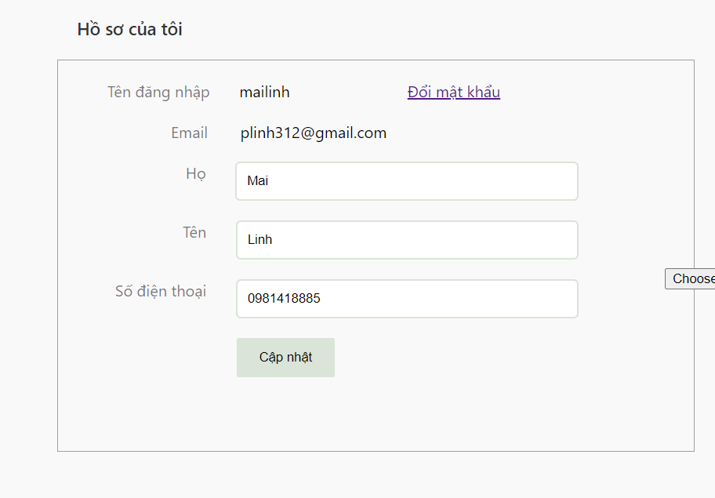

| **Name** | Update profile | **Actor:** all user |
| --- | --- | --- |
| **Description** | This function allows the actor to update personal profile. | |
| **Trigger** | Actor clicks on the “Sửa thông tin cá nhân” in the profile page. | |
| **Preconditions** | 1. Actor has logged in the system.  2. Actors access personal the profile screen. | |
| **Post-conditions** | 1. The system displays a pop-up form with information about the account.  2. The account information in the database has been updated with new information. | |
| **Normal Flows** | Actor action | System responses |
| 1. Edit the information that the actor wants to change.  2. Click on the “Cập nhật” button. | 3. Display message: “Cập nhật thành công” |

**3.3 View own orders and detail order**

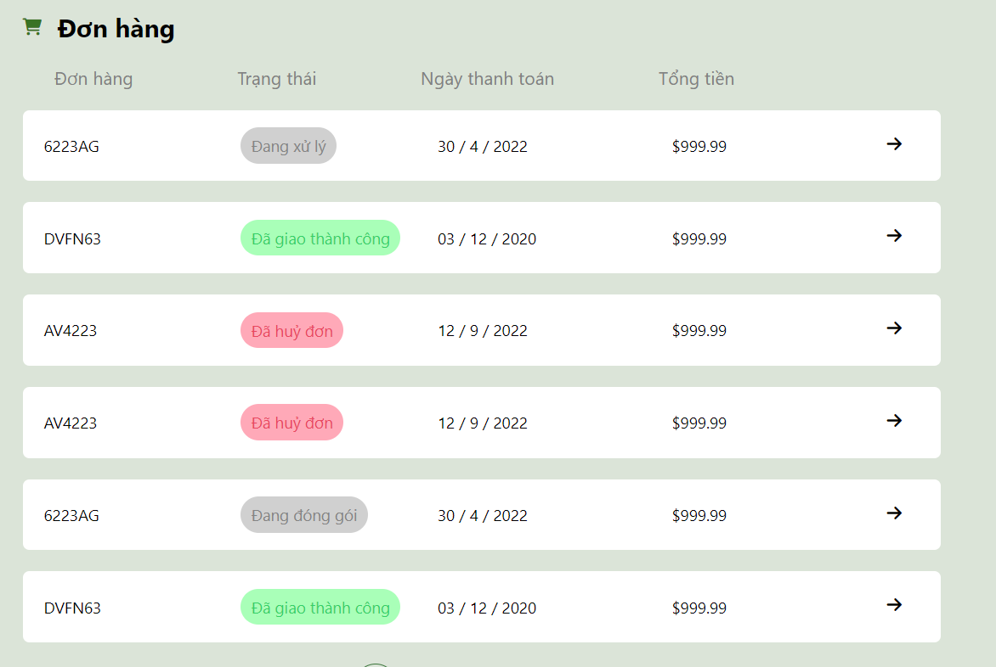

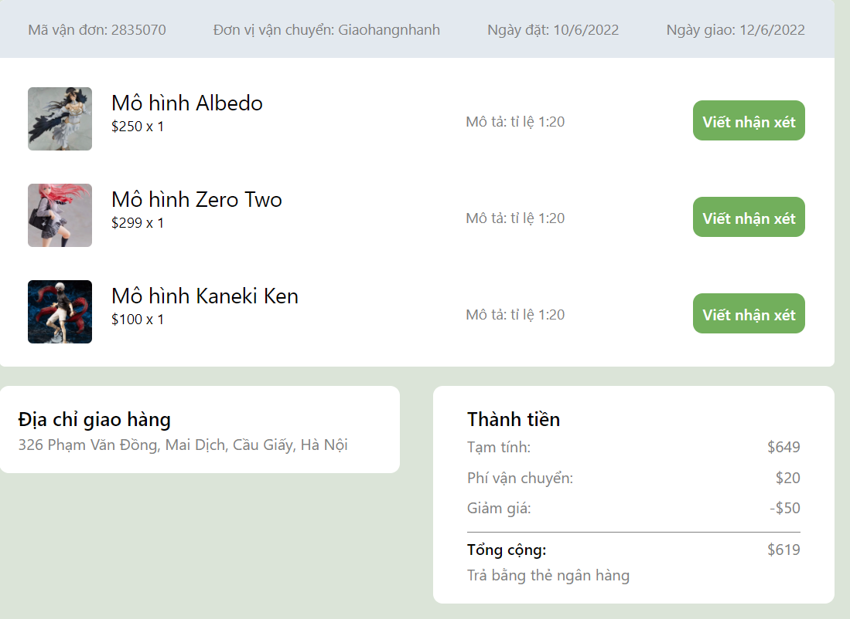

| **Name** | View own orders and order detail | **Actor:** all user |
| --- | --- | --- |
| **Description** | This function allows the actors to view all their orders | |
| **Trigger** | Actor clicks on the “Đơn hàng” in the profile page. | |
| **Preconditions** | 1. Actor has logged in the system.  2. Actors access personal the profile screen. | |
| **Post-conditions** | The system displays a list of orders and information of orders. | |
| **Normal Flows** | Actor action | System responses |
| 1. Click on the “Đơn hàng” in the profile page.  3. Click on the “Chi tiết” button. | 2. Display list of orders.  4. Display detail of order. |

**3.4 Manage address**

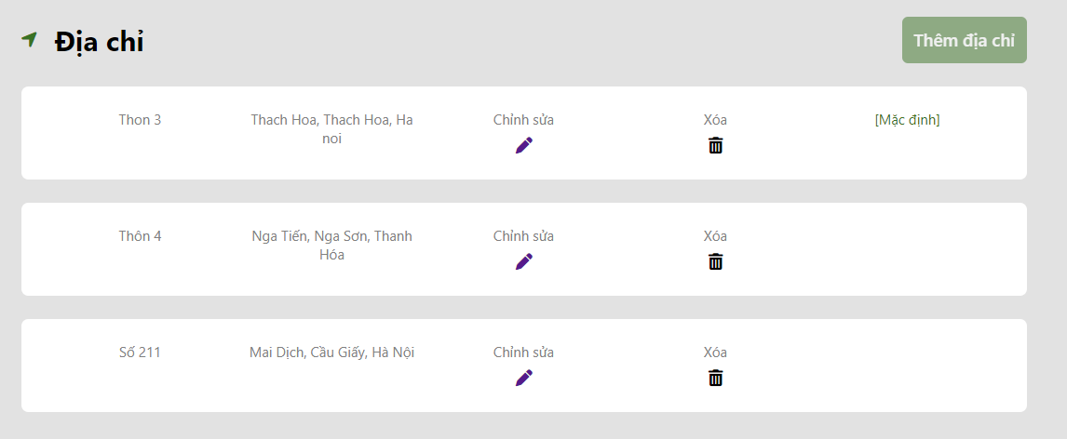

| **Name** | View address | **Actor:** all user |
| --- | --- | --- |
| **Description** | This function allows the actors to view all their addresses | |
| **Trigger** | Actor clicks on the “Địa chỉ” in the profile page. | |
| **Preconditions** | 1. Actor has logged in the system.  2. Actors access personal the profile screen. | |
| **Post-conditions** | The system displays a list of addresses. | |
| **Normal Flows** | Actor action | System responses |
| 1. Click on the “Địa chỉ” in the profile page. | 2. Display list of addresses. |

**3.4.1 Add address**

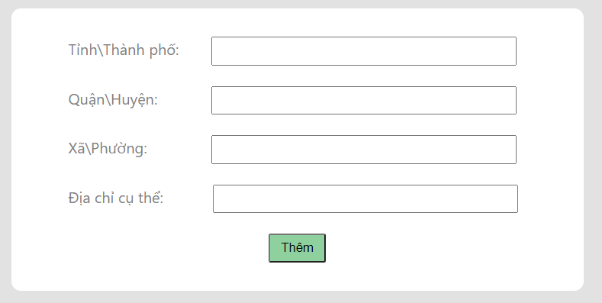

| **Name** | Add address | **Actor:** all user |
| --- | --- | --- |
| **Description** | This function allows the actor to add a new address | |
| **Trigger** | Actor clicks on the “Thêm địa chỉ” in the profile page. | |
| **Preconditions** | 1. Actor has logged in the system.  2. Actors access personal the address screen.  3. The number of address of the user must <= 3 | |
| **Post-conditions** | The system adds a new address and save into database. | |
| **Normal Flows** | Actor action | System responses |
| 1. Click on the “Thêm địa chỉ” in the profile page.  3. Click on the button “Thêm” | 2. Display a pop-up form to input address’s information.  4. Send redirect to view address page |

**3.4.2 Edit address**

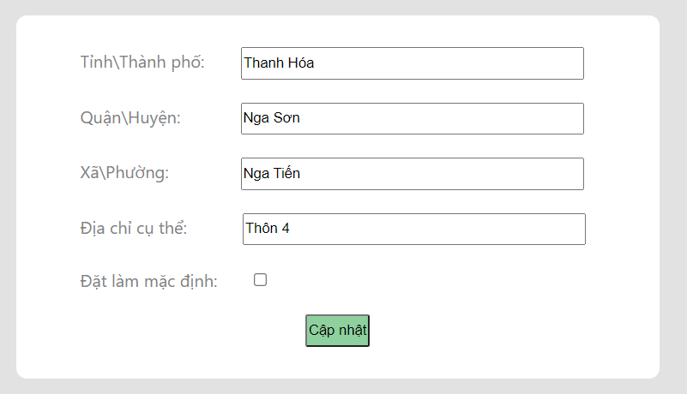

| **ID and Name** | Edit address | **Actor:** all user |
| --- | --- | --- |
| **Description** | This function allows the actor to edit a address | |
| **Trigger** | Actor clicks on the pen icon in the view address page. | |
| **Preconditions** | 1. Actor has logged in the system.  2. Actors access personal the address screen. | |
| **Post-conditions** | The system updates address and save into database | |
| **Normal Flows** | Actor action | System responses |
| 1. Click on the pen icon in the view address page.  3. Click on the button “Cập nhật” | 2. Display a pop-up form to input address’s information.  4. Send redirect to view address page |

**3.4.3 Delete address**

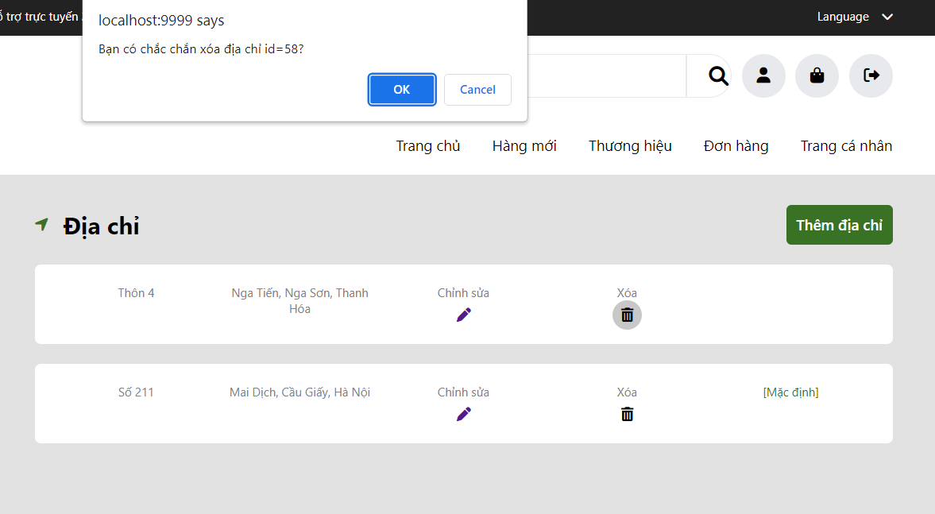

| **ID and Name** | Delete address | **Actor:** all user |
| --- | --- | --- |
| **Description** | This function allows the actor to delete a address | |
| **Trigger** | Actor clicks on the bin icon in the view address page. | |
| **Preconditions** | 1. Actor has logged in the system.  2. Actors access personal the address screen. | |
| **Post-conditions** | The system delete address from database | |
| **Normal Flows** | Actor action | System responses |
| 1. Click on the bin icon in the view address page.  3. Click on the button “Cập nhật” | 2. Display message “Bạn chắc chắn muốn xóa địa chỉ?”.  4. Send redirect to view address page |

**3.5 Change password**

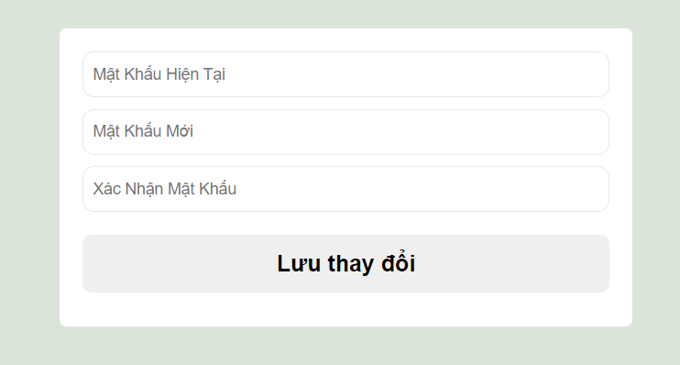

| **ID and Name** | Change password | **Actor:** all user |
| --- | --- | --- |
| **Description** | This function allows the actor to change password | |
| **Trigger** | Actor clicks on the “Đổi mật khẩu” in the change profile page. | |
| **Preconditions** | 1. Actor has logged in the system.  2. Actors access personal the change profile screen. | |
| **Post-conditions** | 1. The system displays a form to change password  2. The change is update in database | |
| **Normal Flows** | Actor action | System responses |
| 1. Clicks on the “Đổi mật khẩu” in the change profile page.  3. Enter new address  4. Click button “Thêm” | 2. System responses a form that requests entering information.  5. Redirect to view address page. |

### **4. Manage product**

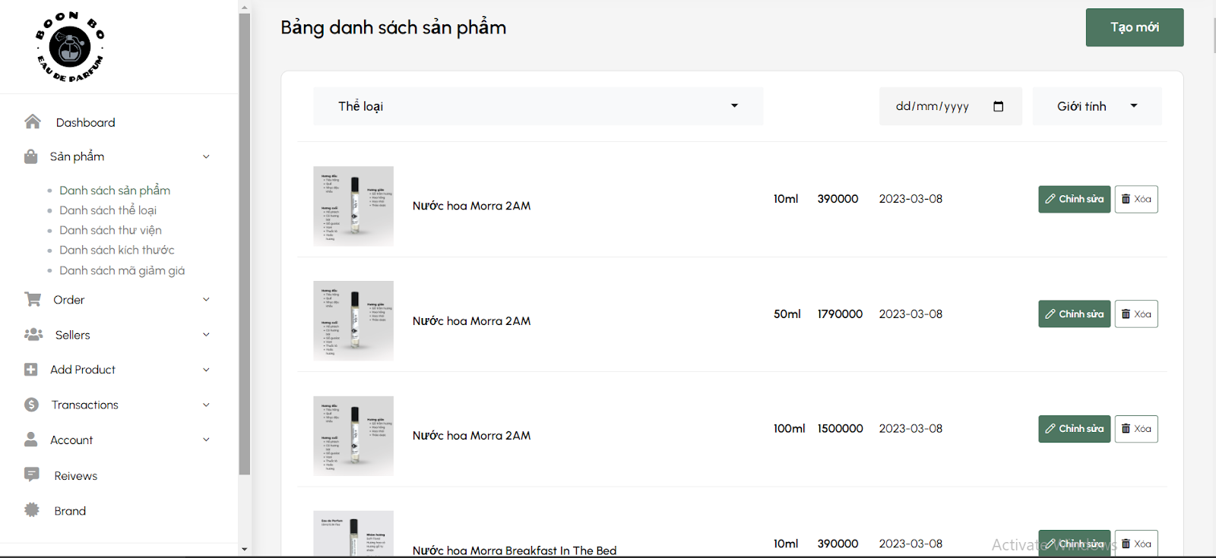

| **ID and Name** | Manage Product | **Actor:** admin, staff |
| --- | --- | --- |
| **Description** | This function allows actors to choose one of the products to manage. | |
| **Trigger** | Actor clicks on “Danh sách sản phẩm” | |
| **Preconditions** | **PRE-1**. Actor has logged in the system with a admin account | |
| **Post-conditions** | **POST-1**. The system displays a menu to manage products. | |
| **Normal Flows** | Actor action | System responses |
| 1. Click on “Danh sách sản phẩm” | 2. Display a list of products |

**4.1 Update product**

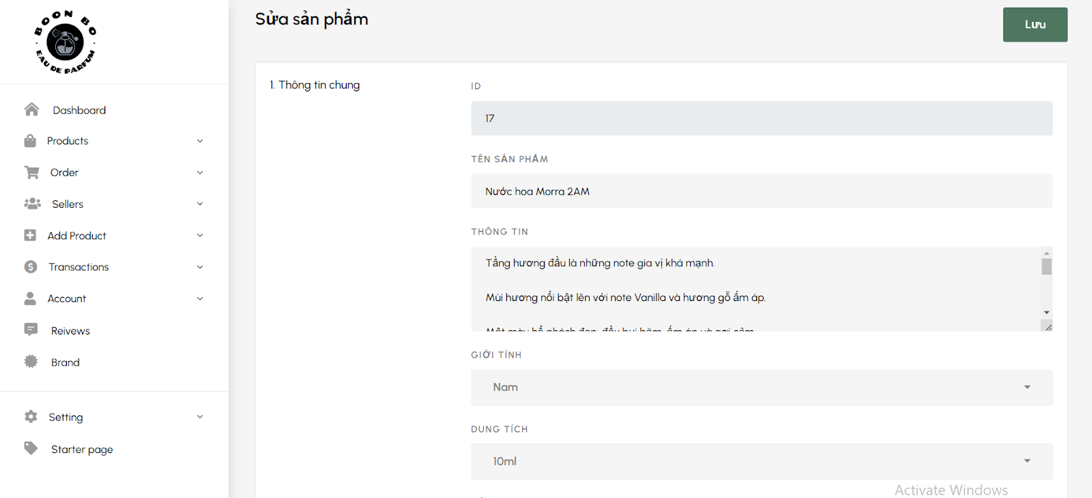

| **ID and Name** | Update Product | **Actor:** admin, staff |
| --- | --- | --- |
| **Description** | This function allows actors to update information about a product. | |
| **Trigger** | Actor clicks on the “Chỉnh sửa”. | |
| **Preconditions** | **PRE-1.** Actor has logged in the system with an admin account.  **PRE-2.** Actor accesses the product management page**. PRE-3.** Product list must have at least 1 product. | |
| **Post-conditions** | **POST-1.** The system displays a list of products with updated products .  **POST-2.** The product information in the database has been updated with new information. | |
| **Normal Flows** | Actor action | System responses |
| 1. Click on the “chỉnh sửa” icon at the row which has the product to update.  3. Update the information that the actor wants to change.  4. Click the “Lưu” button | 2. Display a pop-up form to edit product information.  5. Display message: “Đã lưu”. |

**4.2 Delete product**



| **ID and Name** | Delete Product | **Actor:** admin, staff |
| --- | --- | --- |
| **Description** | This function allows actors to delete products | |
| **Trigger** | Actor clicks on the “Xóa”. | |
| **Preconditions** | **PRE-1.** Actor has logged in the system with an admin account.  **PRE-2.** Actor accesses the product management page**. PRE-3.** Product list must have at least 1 product. | |
| **Post-conditions** | **POST-1.** The system displays a list of products without a deleted product.  **POST-2.** The product information in the database has been removed. | |
| **Normal Flows** | Actor action | System responses |
| 1. Click on the delete icon at the row which has the product to delete.  3. Click the “Có” button. | 2. Display a pop-up message: “Bạn muốn xóa sản phẩm này?”  4. Display message: “Xóa thành công” |

**4.3 Add product**

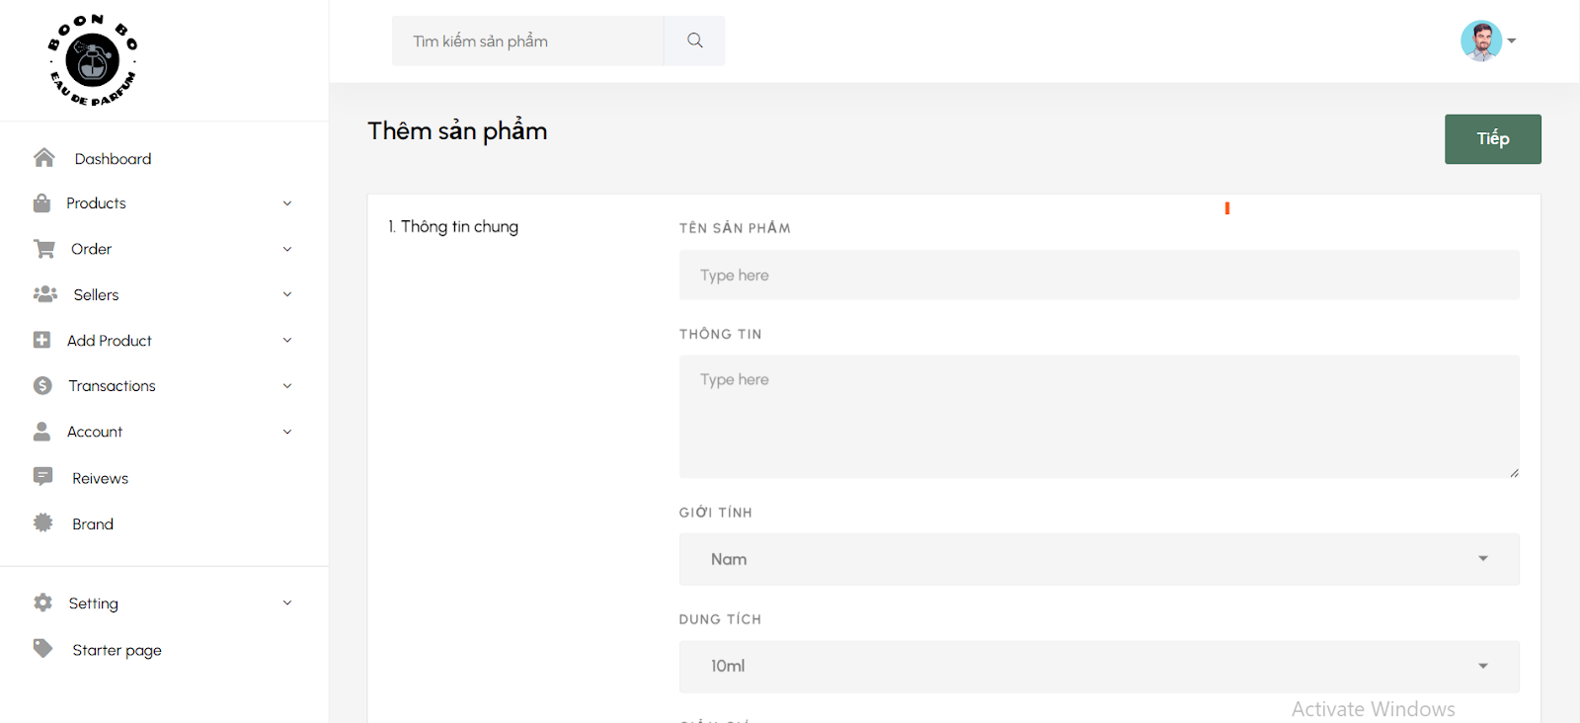

| **ID and Name** | Add Product | **Actor:** admin, staff |
| --- | --- | --- |
| **Description** | This function allows actors to add new product | |
| **Trigger** | Actor clicks on the “Tạo mới”. | |
| **Preconditions** | **PRE-1.** Actor has logged in the system with an admin account.  **PRE-2.** Actor accesses the product management page**.** | |
| **Post-conditions** | **POST-1.** The system displays a list of products with a new product added.  **POST-2.** A new product has been added to the database. | |
| **Normal Flows** | Actor action | System responses |
| 1. Click on the “Tạo mới” button.  3. Input new product information.  4. Click on the “Tiếp” button. . | 2. Display a pop-up form to fill in the information of the new product.  5. Display a message: “Thêm sản phẩm thành công”. |

**4.4 View product**

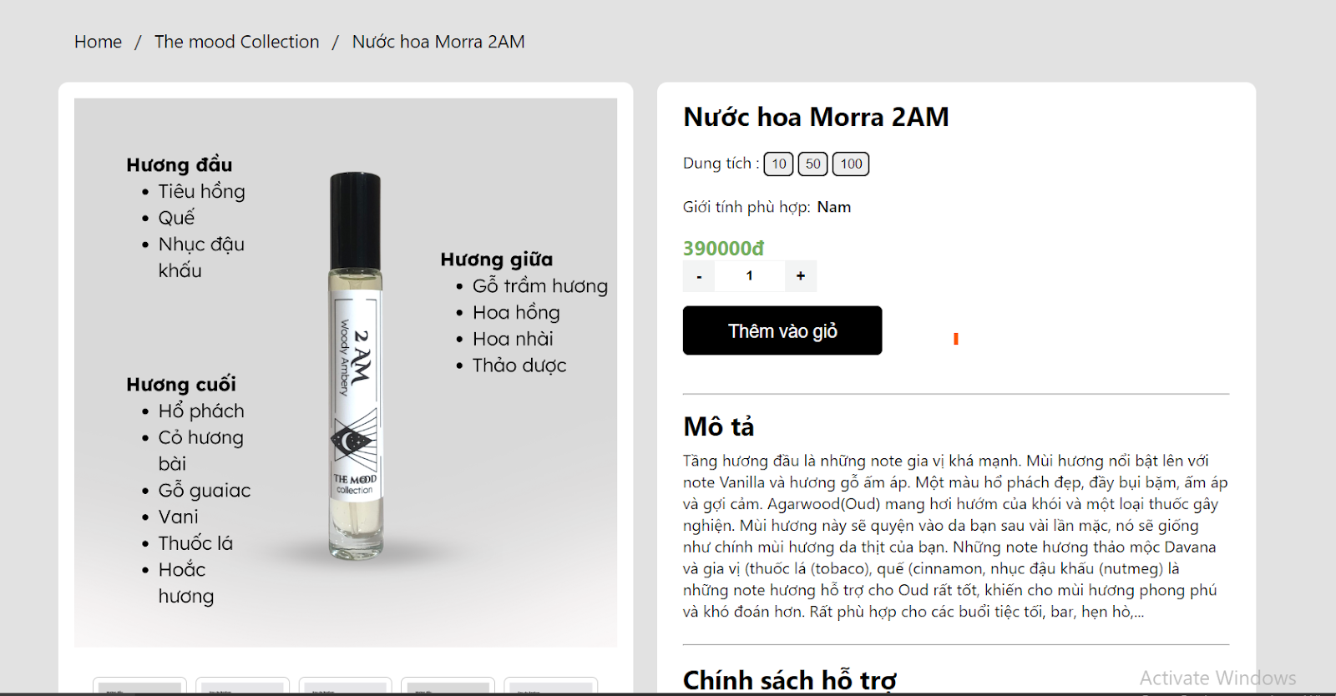

| **ID and Name** | View Product | **Actor:** admin, staff |
| --- | --- | --- |
| **Description** | This function allows actors to view products. | |
| **Trigger** | Actor clicks on the title or thumbnail of the product.. | |
| **Preconditions** | **PRE-1.** Actor has logged in the system with an admin account.  **PRE-2.** Actor accesses the product management page**. PRE-3.** Product list must have at least 1 product. | |
| **Post-conditions** | **POST-1.** The system displays information about product | |
| **Normal Flows** | Actor action | System responses |
| 1. Click on the title or thumbnail of the product to view information | 2. Display product information. |

### **5. Action with shopping cart**

| **ID and Name** | Add to cart | **Actor**: all users |
| --- | --- | --- |
| **Description** | This function allows the customer add quantity to cart | |
| **Trigger** | Actor change in input quantity in cart page | |
| **Preconditions** | 1. Actor has logged in the system with an user account  2. Customers must add at least 1 product to cart | |
| **Post-conditions** | 1. The shopping cart is changed, the price information also changes | |
| **Normal Flows** | **Actor action** | **System responses** |
| 1.Go cart page by click icon cart  2. Input quantity in input box | 3. Information will change and save in cookie |

| **ID and Name** | Delete to cart | **Actor**: customer |
| --- | --- | --- |
| **Description** | This function allows the customer delete item to cart | |
| **Trigger** | Actor click icon “Delete” | |
| **Preconditions** | 1. Actor has logged in the system with an user account  2. Customers must add at least 1 product to cart | |
| **Post-conditions** | 1. The product will be removed from the cart. If you delete all products, the message "No products in order" will appear. | |
| **Normal Flows** | **Actor action** | **System responses** |
| 1.Go cart page by click icon cart  2. Click icon “Delete” | 3. Product list will change |

### **6. Feedback**

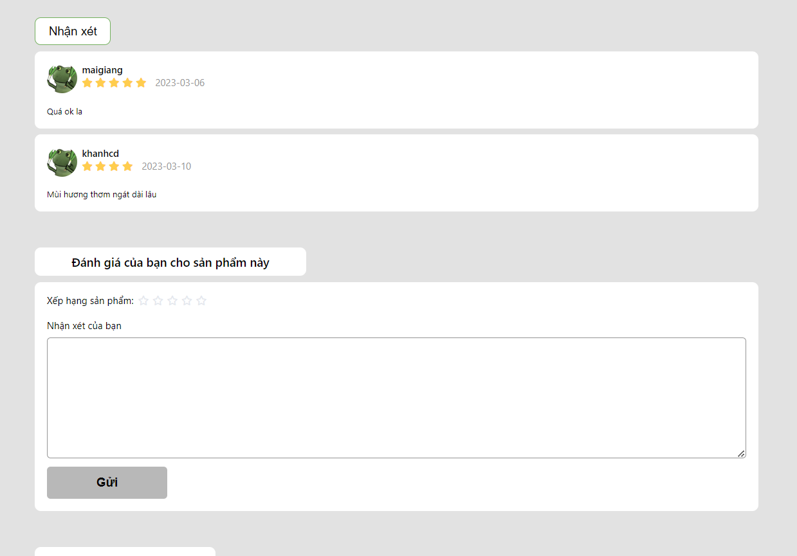

| **ID and Name** | Feedback | **Actor:** customer |
| --- | --- | --- |
| **Description** | This function allows the customer to add feedback when the order is done. | |
| **Trigger** | Actor clicks on the “Gửi” button in product detail page. | |
| **Preconditions** | 1. Actor has logged in the system with an user account  2. Customers must order successfully.  3. The customer has not commented on that order yet | |
| **Post-conditions** | 1. Add successfully and display feedback in detail product page | |
| **Normal Flows** | **Actor action** | **System responses** |
| 1.Vote rate  2. Input comment  3. Click on the “Gửi” button in the feedback section. | 5. Save data to DB  6. Returns a feedback list for each specific product |

### **7. Common feature**

**7.1 Register**

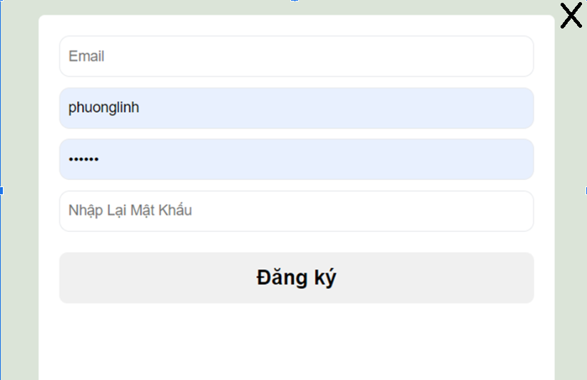

| **ID and Name** | Register | **Actor:** all users |
| --- | --- | --- |
| **Description** | This function allows the actor to register a new. account. | |
| **Trigger** | Actor clicks on the “Đăng ký” button in the navigation bar | |
| **Preconditions** | **PRE-1.** The actor does not have an account  **PRE-2.** The actor accesses the homepage without login status | |
| **Post-conditions** | **POST-1. T**he system displays message: “Tạo tài khoản thành công”**.**  **POST-2.** The system saves user information to the database. | |
| **Normal Flows** | **Actor actions System responses** | **Actor actions System responses** |
| 1. Click on the “Đăng ký” button in the navigation bar. 3. Fill in personal information. 4. Click on the “Đăng ký” button in the pop-up form. | 2. Display pop-up form to fill in user information.  5. Display message: “Đăng ký thành công” |

**7.2 Login**

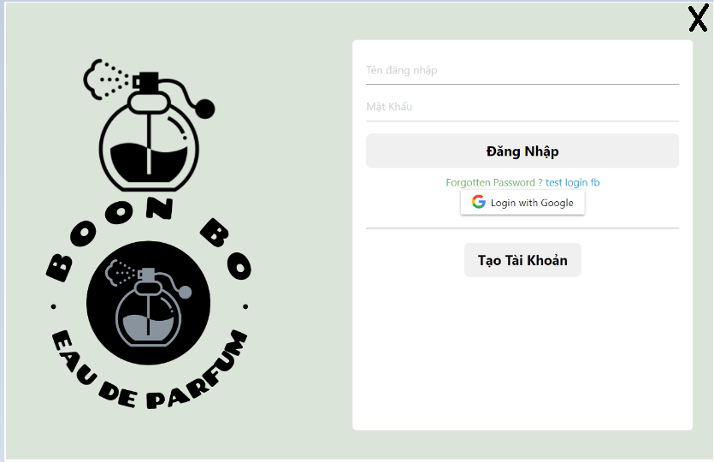

| **ID and Name** | Login | **Actor:** all users |
| --- | --- | --- |
| **Description** | Actors use this function to log in the system with the account. | |
| **Trigger** | Actors click on the “Đăng nhập” button in the navigation bar. | |
| **Preconditions** | **PRE-1.** Actors are not signed in the system  **PRE-2.** Actors have owned an account. | |
| **Post-conditions** | **POST-1.** Actor logged in to the system  **POST-2.** The system saved the actor's successful login status | |
| **Normal Flows** | **Actor actions System responses** | **Actor actions System responses** |
| 1. Access website without login status.  2. Click on the “Đăng nhập” button in the navigation bar.  4. Enter username, password.  5. Click on the “Đăng nhập” button in the pop-up form | 3. Display pop-up form to fill in account information.  6. Display home page if authentication is successful. |

**7.3 Logout**

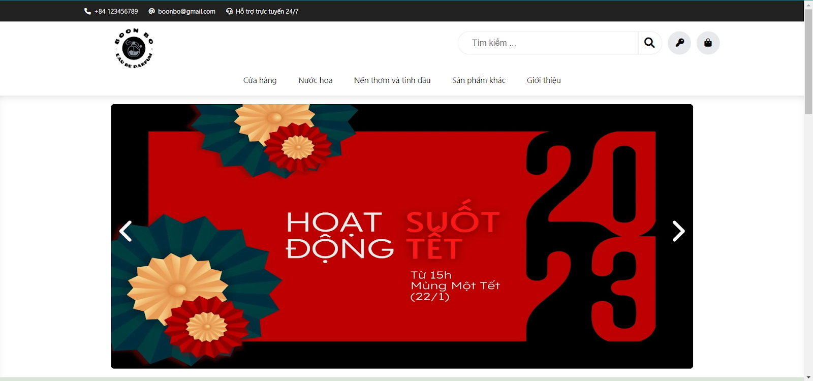

| **ID and Name** | Logout | **Actor:** all users |
| --- | --- | --- |
| **Description** | Actors use this function to log out the system. | |
| **Trigger** | Actors click on the “Đăng xuất” icon. | |
| **Preconditions** | **PRE-1.** Actors have logged into the system. | |
| **Post-conditions** | **POST-1.** Actors logged out of the system  **POST-2.** The system saved the actor's successful logout status and ended the session | |
| **Normal Flows** | **Actor actions System responses** | **Actor actions System responses** |
| 1. Click on the logout icon in the navigation bar | 2. Display a drop-down menu.  3. Display homepage without login status |

**7.4: Forgot password パスワードを忘れる**

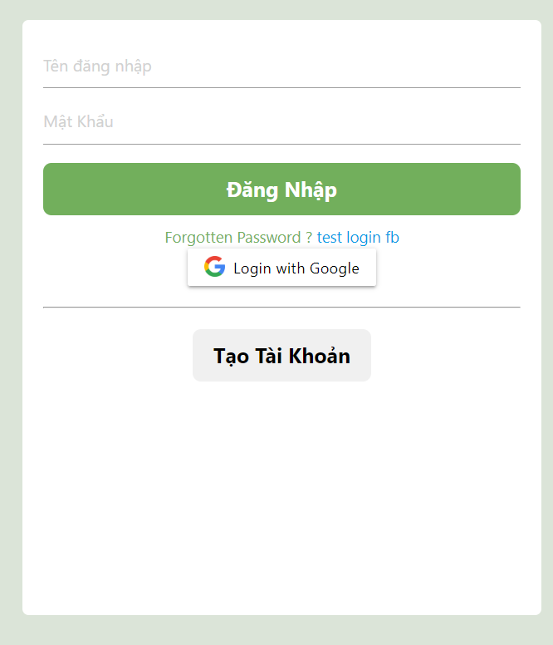

| **ID and Name** | Forgotpass | **Actor:** User, Order manager, Admin, Stock manager |
| --- | --- | --- |
| **Description** | Actors use this function to change the password because they have forgotten it. | |
| **Trigger** | Actors click on the “Đăng xuất” icon. | |
| **Preconditions** | **PRE-1.** . Actors have been on Login Screen. | |
| **Post-conditions** | **POST-1.** Successfully changed to a new password**.** | |
| **Normal Flows** | **Actor actions System responses** | **Actor actions System responses** |
| 1. Click on the the “Quên mật khẩu?” button on Login Screen.  3. Input valid email existing on the system  6. Input otp value from email to otp form  8. Input the new password and confirm | 2. Display forgot password pop-up with textbox for inputting email.  4. A successful message is displayed to announce the user to check the mail.  5. Send a mail to user  7.Redirect to the change new password page  9. Display a successful message and go to login |

**7.5 Search product**

**7.5.1 Search product by name**

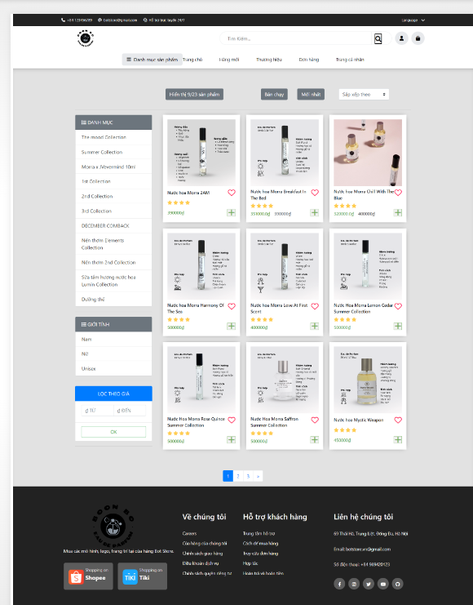

| **ID and Name** | Search product by name | **Actor:** all users |
| --- | --- | --- |
| **Description** | Actor searches questions by inputting keywords into the search box. | |
| **Trigger** | Actor inputs the keyword into the search box | |
| **Preconditions** | **PRE-1.** . Actor accesses the shop page.. | |
| **Post-conditions** | **POST-1.** The system displays results with list information of products that contain entered keywords**.** | |
| **Normal Flows** | **Actor actions System responses** | **Actor actions System responses** |
| 1. Input keyword in the search box | 2. Display the search results. |

**7.5.2 Search product by price**

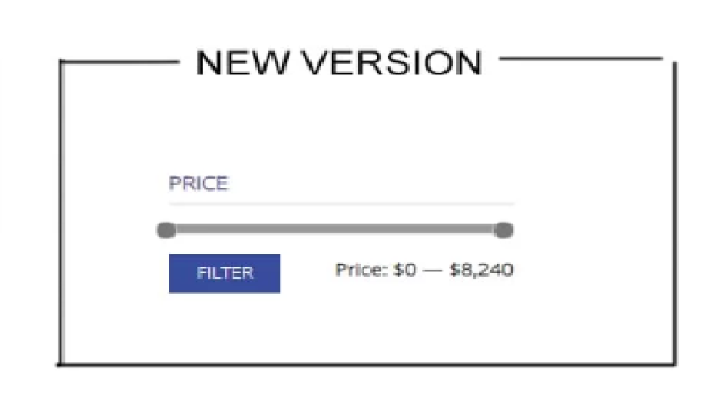

| **ID and Name** | Search by price | **Actor**: all users |
| --- | --- | --- |
| **Description** | This function allows the customer search list product by price | |
| **Trigger** | Click “Filter” to search | |
| **Preconditions** | 1. Actor has logged in the system with an user account  2. Customers must go to shop page | |
| **Post-conditions** | 1.Display a list product for price-range | |
| **Normal Flows** | **Actor action** | **System responses** |
| 1.Go shop page by click icon cart  2. Actor change use filter-range and click “Filter” to search | 3. System received a range-price and return a list products |

**7.5.3 Search product by category, gender**

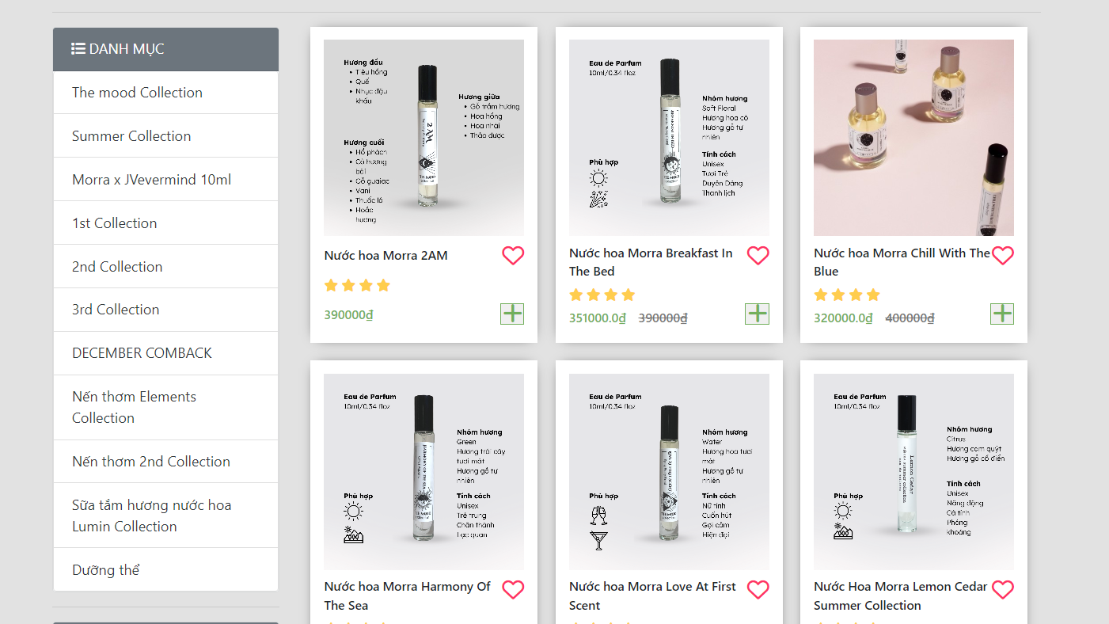

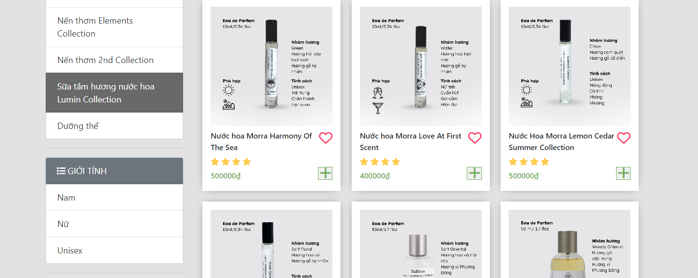

| **ID and Name** | Search by category, gender | **Actor:** all users |
| --- | --- | --- |
| **Description** | Users find products by selecting categories or genders on the left side of the screen. | |
| **Trigger** | Actor click the link of category or gender | |
| **Preconditions** | **PRE-1.** Actor accesses the shop page. | |
| **Post-conditions** | **POST-1.** The system displays results with list information of products belong to each category and gender. | |
| **Normal Flows** | **Actor actions System responses** | **Actor actions System responses** |
| 1.click the link of category or gender. | 2. Display the search results. |

**7.6 Home page**

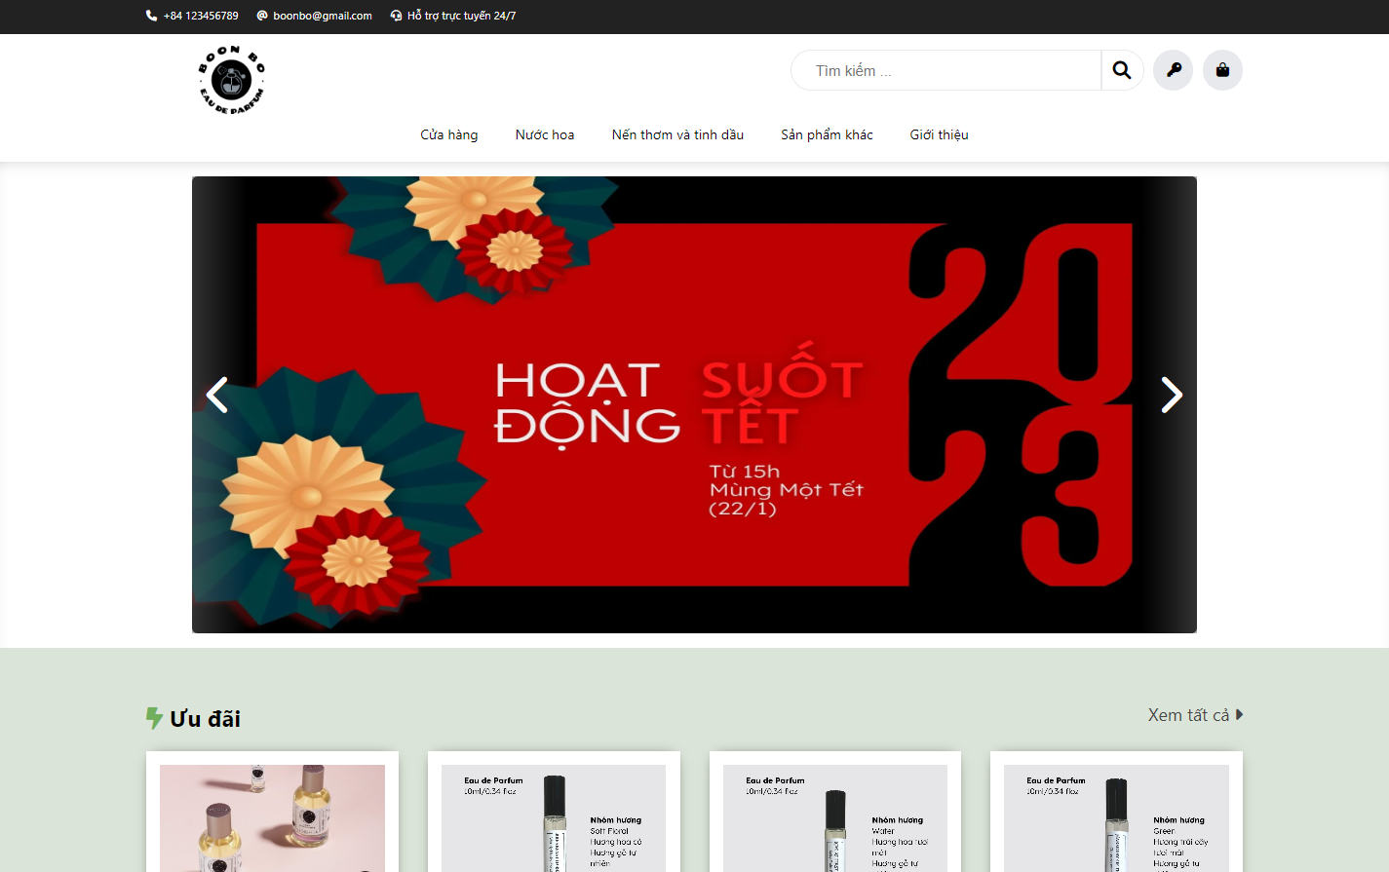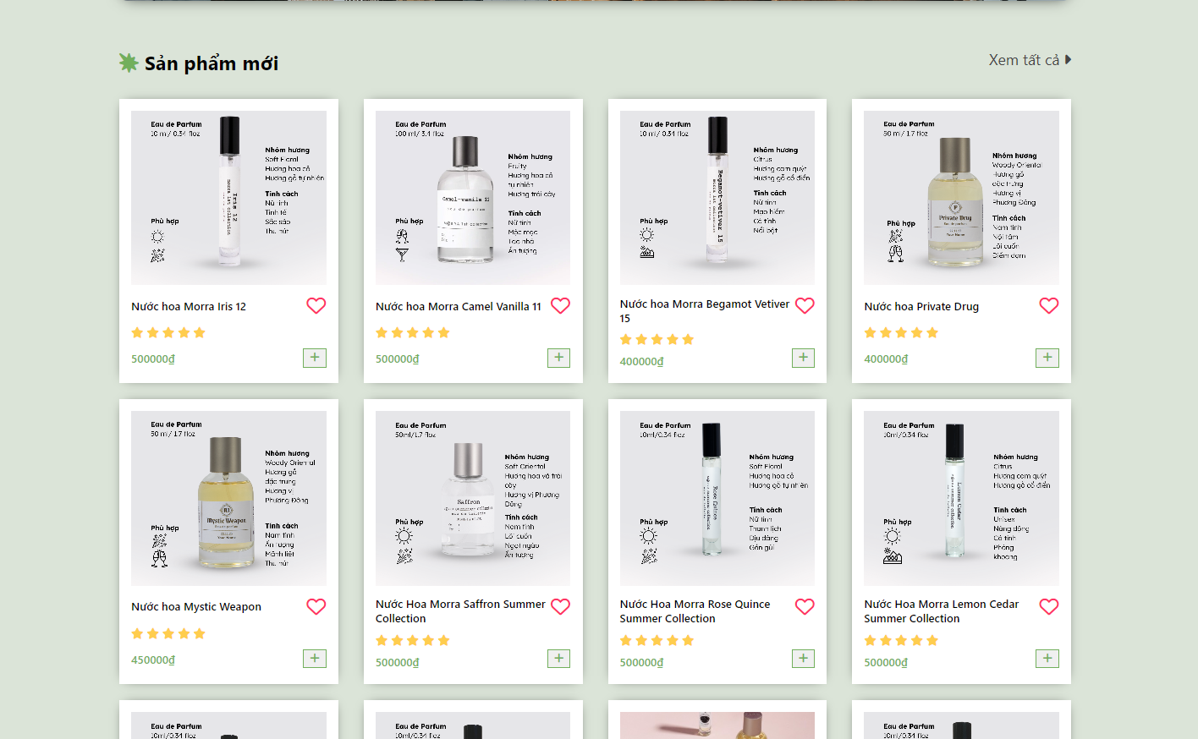

| **ID and Name** | View homepage | **Actor:** User, Order manager, Admin, Stock manager |
| --- | --- | --- |
| **Description** | Show a top list new product, a seller product and navigation bar. | |
| **Trigger** | Actor want to home page to typical products | |
| **Preconditions** | **PRE-1.** . Actor accesses the shop page.. | |
| **Post-conditions** | **POST-1.** Latest and best-selling product listings are displayed on the page | |
| **Normal Flows** | **Actor actions System responses** | **Actor actions System responses** |
| 1. Go to home page | 2. Display the home screen |